Faculty Management System

In this project we are designing online web application for faculties and students where they can manage all their teaching and subjects’ details at a single centralized servers. This project consists of following modules

1. Admin: admin can login to system using username and password as ‘admin’ and then can add new student and faculties details. Admin will give login details to both faculty and students. Admin can view list of available faculties and students
2. Faculty: faculty can login to system using login details given by admin, after login faculty can schedule his lecture class, manage publication, upload mark sheets and manage other professional sessions like Review, Invigilation etc.
3. Student: student can login to system using login details given by admin and then can view all reporting related to faculties such as viewing and downloading marks, view faculty engagements, view scheduled lectures and publications done by faculties.

To run project install python 3.7 and then install MYSQL database and then copy content from DB.txt file and then paste in MYSQL console to create database.

SCREEN SHOTS

Double click on ‘run.bat’ file to start python web DJANGO server and get below page

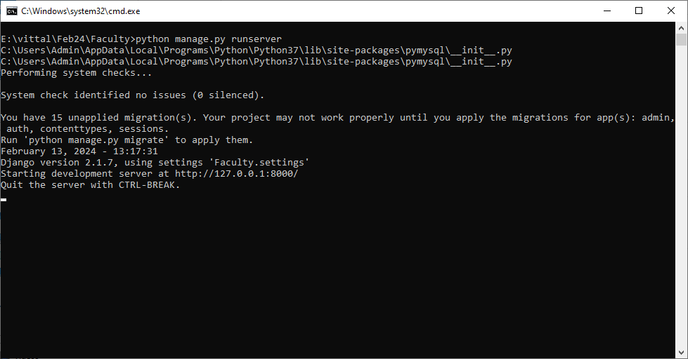

In above screen python server started and now open browser and enter URL as <http://127.0.0.1:8000/index.html> and press enter key to get below page

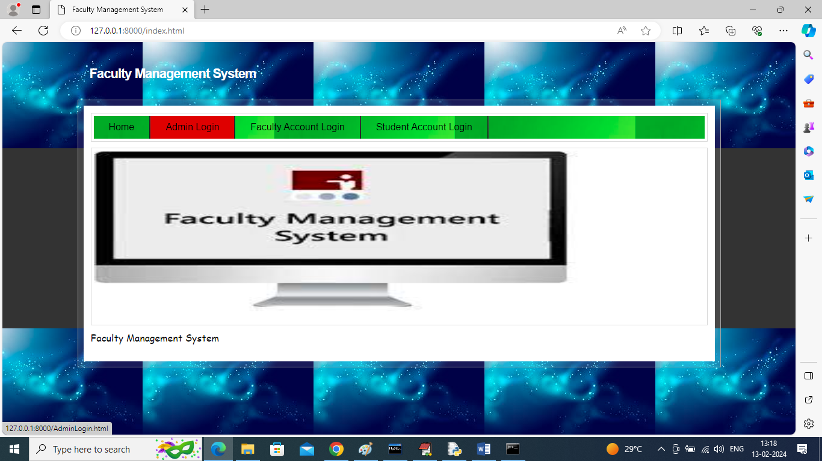

In above screen click on ‘Admin Login’ link to get below page

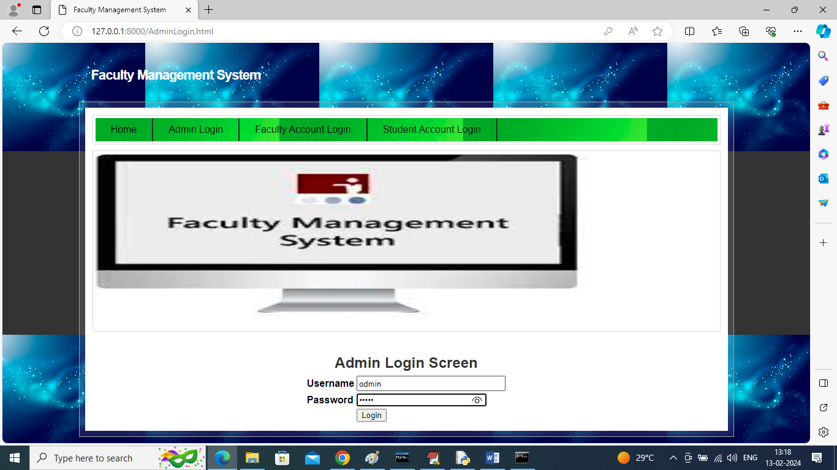

In above screen admin is login and after login will get below page

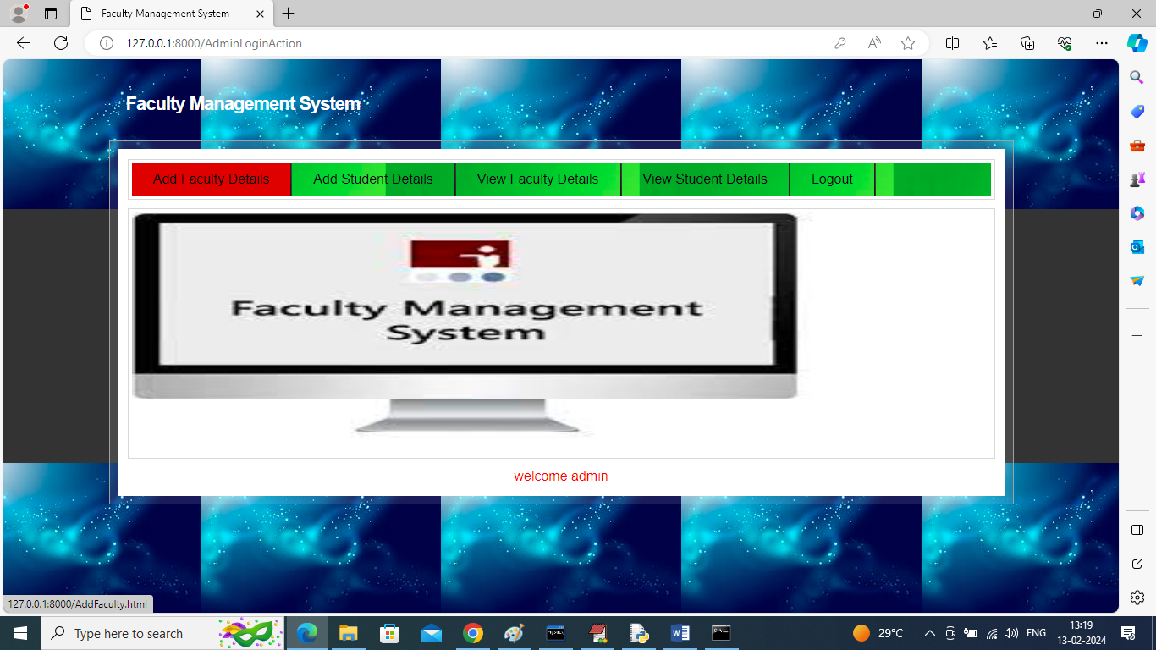

In above screen click on ‘Add Faculty Details’ link to get below page

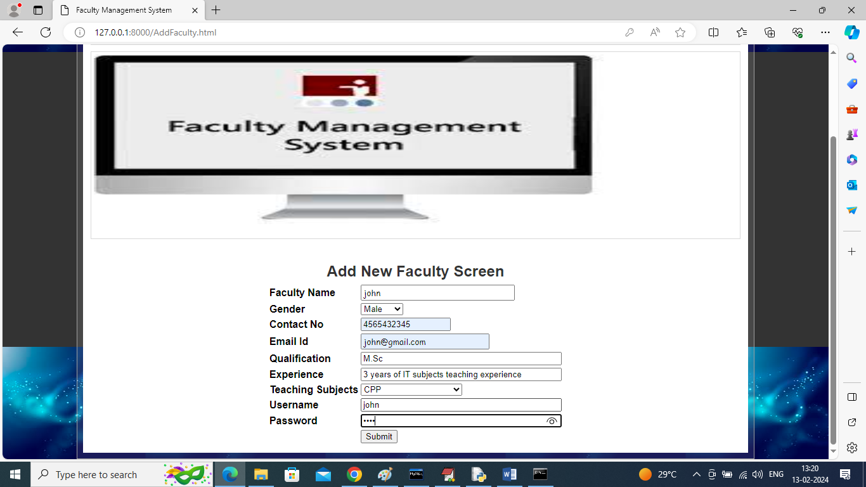

In above screen admin adding new faculty details and then press button to get below page

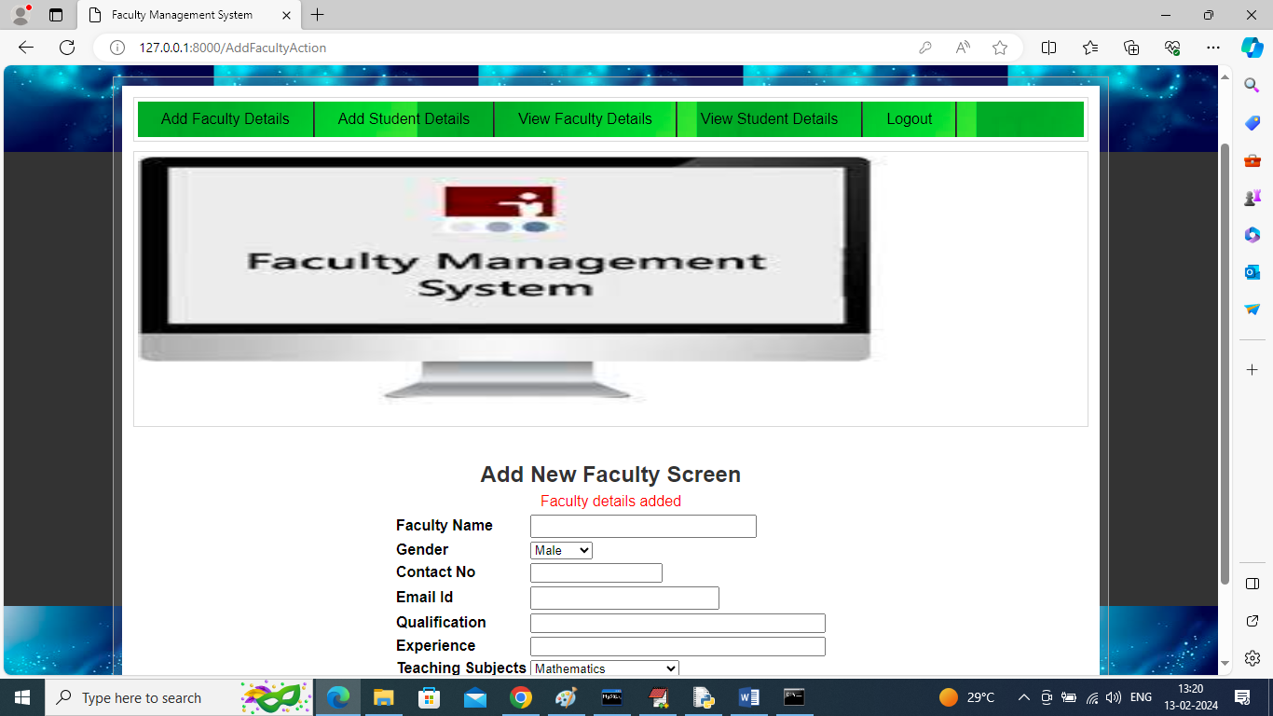

In above screen faculty details added and now click on ‘Add Student’ link to add student details

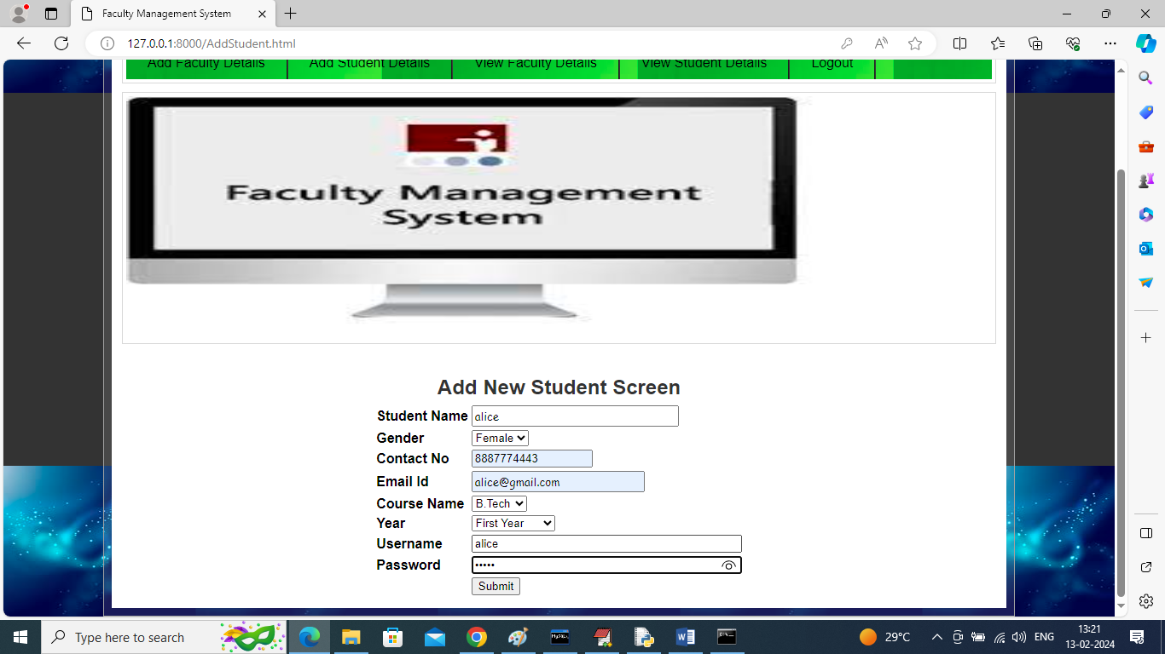

In above screen admin adding student details and then click on ‘Submit’ button to get below page

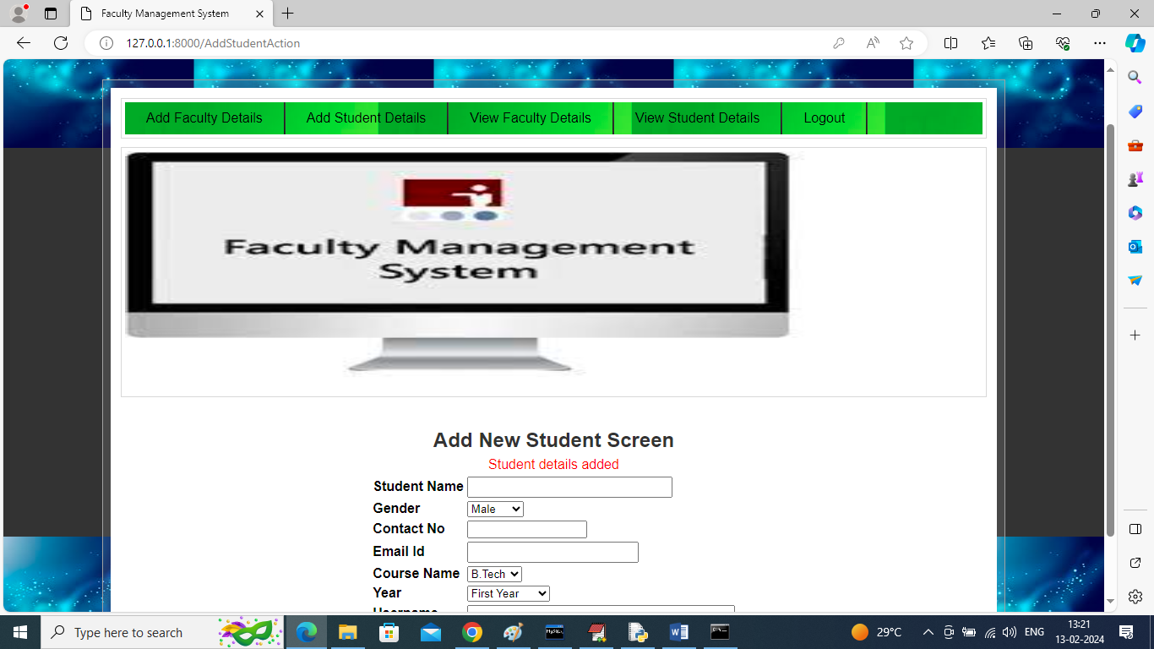

In above screen student details added and now click on ‘View Faculty Details’ link to view list of available faculties

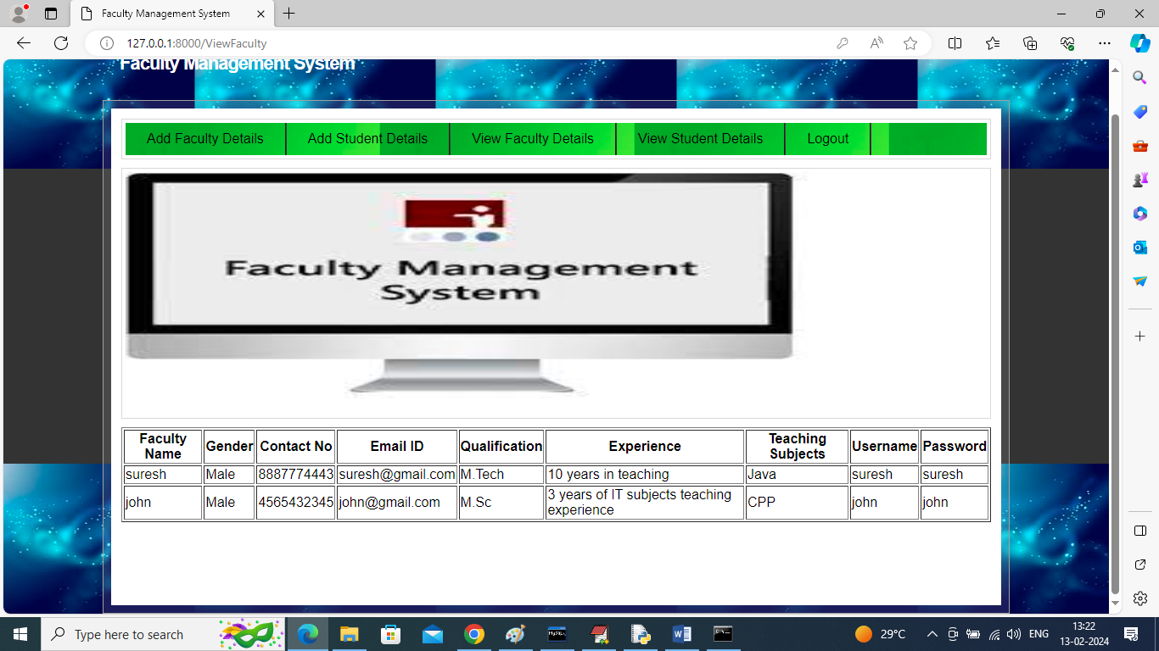

In above screen admin can view list of available faculty details and now click on ‘View Student Details’ to view list of students

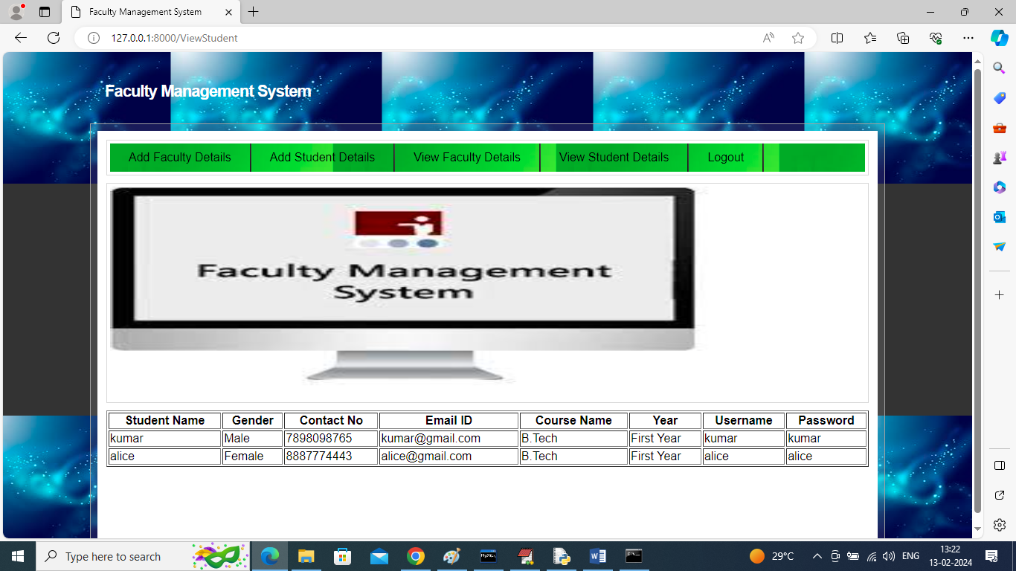

In above screen admin can view list of available students and now logout and login as Faculty

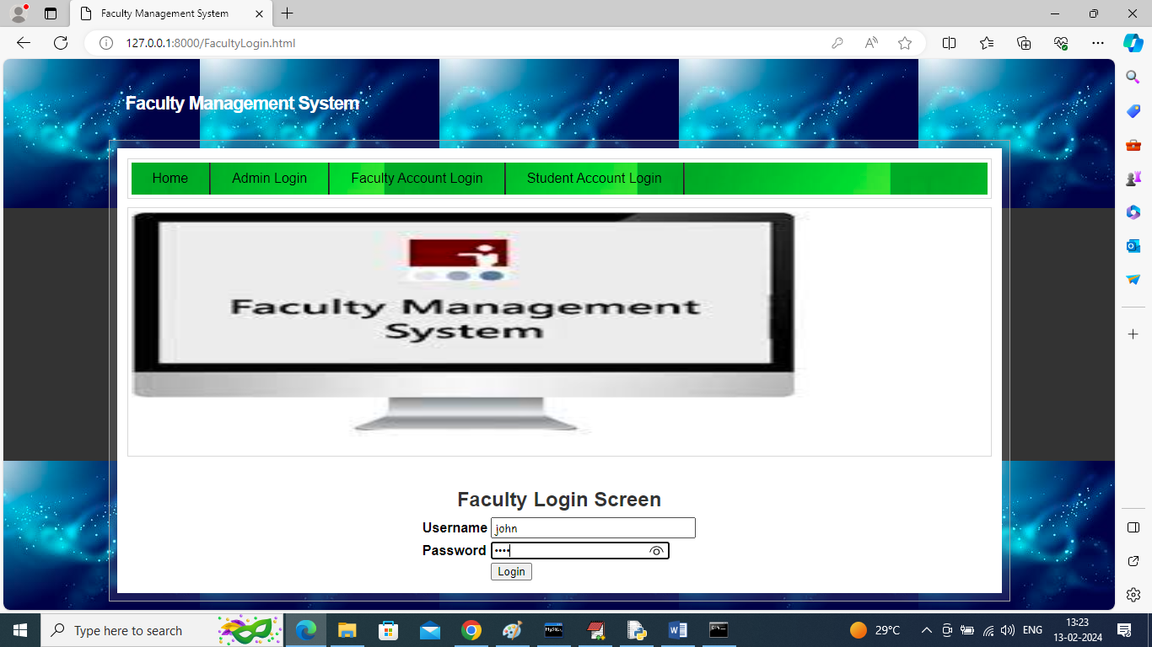

In above screen faculty is login and after login will get below page

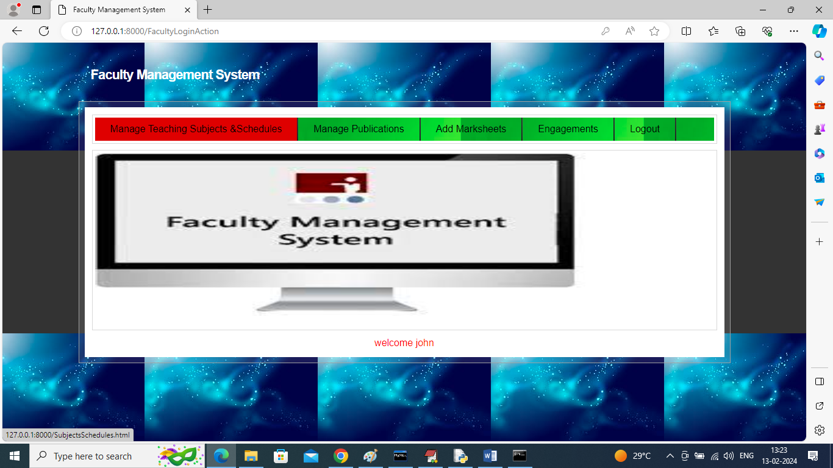

In above screen faculty can click on ‘Manage Teaching Subjects & Schedules’ link to add lecture details

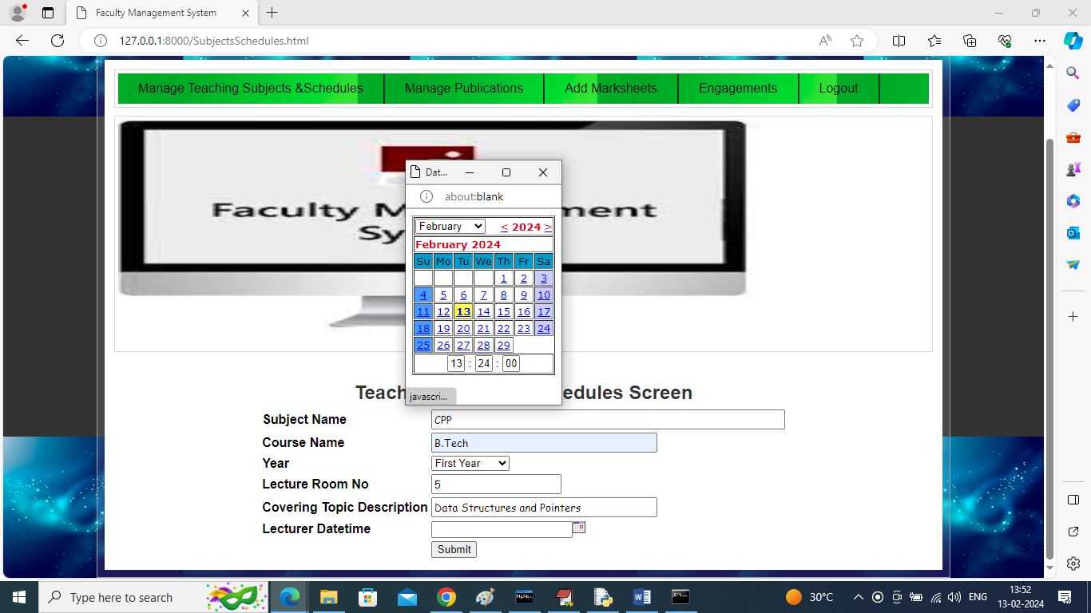

In above screen faculty will add lecture details along with lecture room, subject with date and time and then press button to schedule lecture and get below output

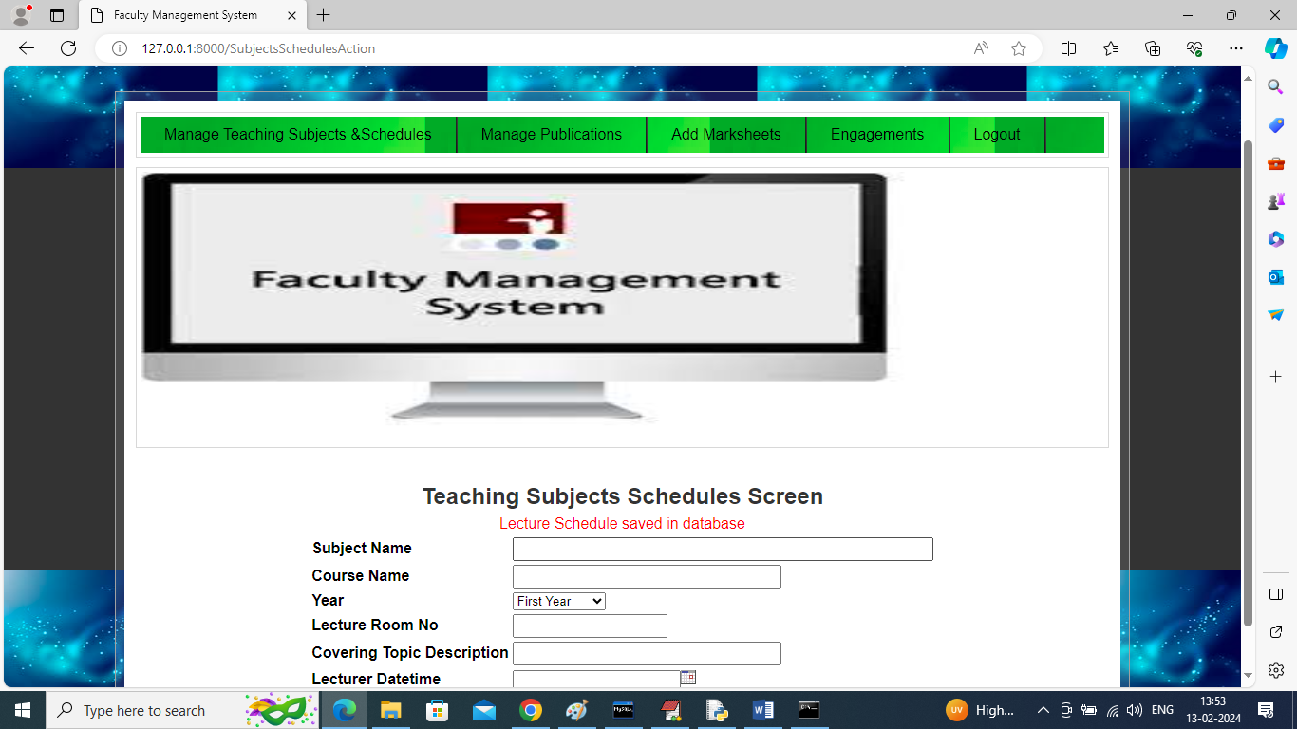

In above screen lecture details added and now click on ‘Manage Publications’ link to add research work and publish paper details

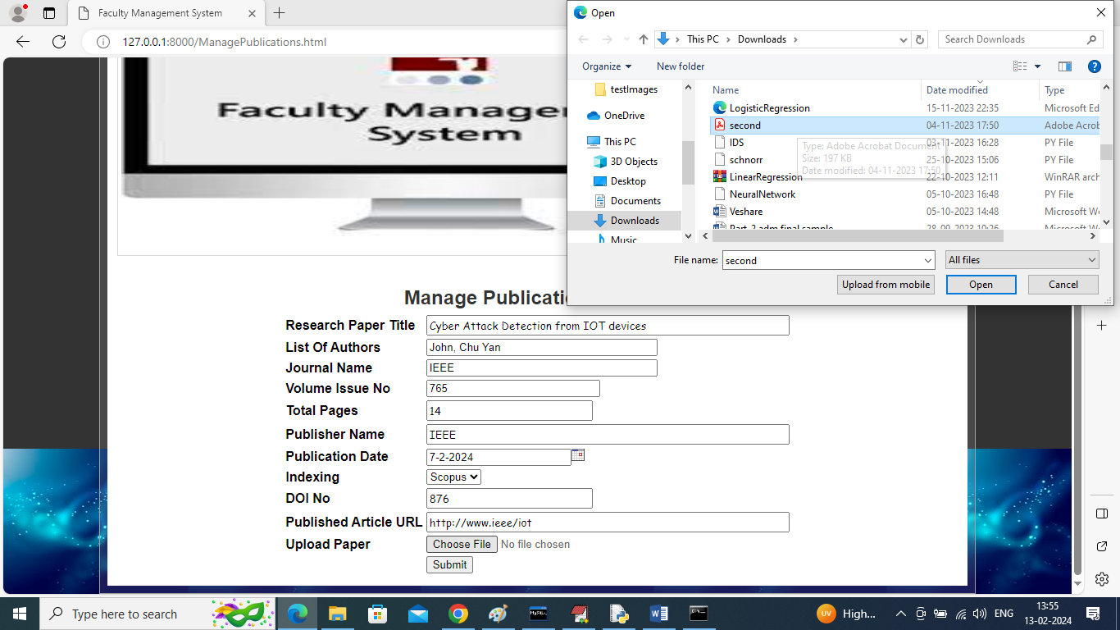

In above screen faculty will add all his research publication details along with paper and then press button to save details and get below output

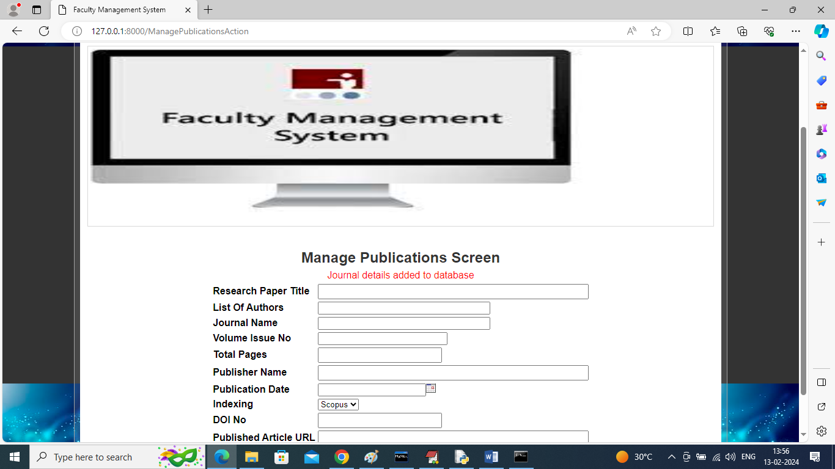

In above screen all research journal publishing paper details added and now click on ‘Add Mark sheets’ link to upload excel or any other format file

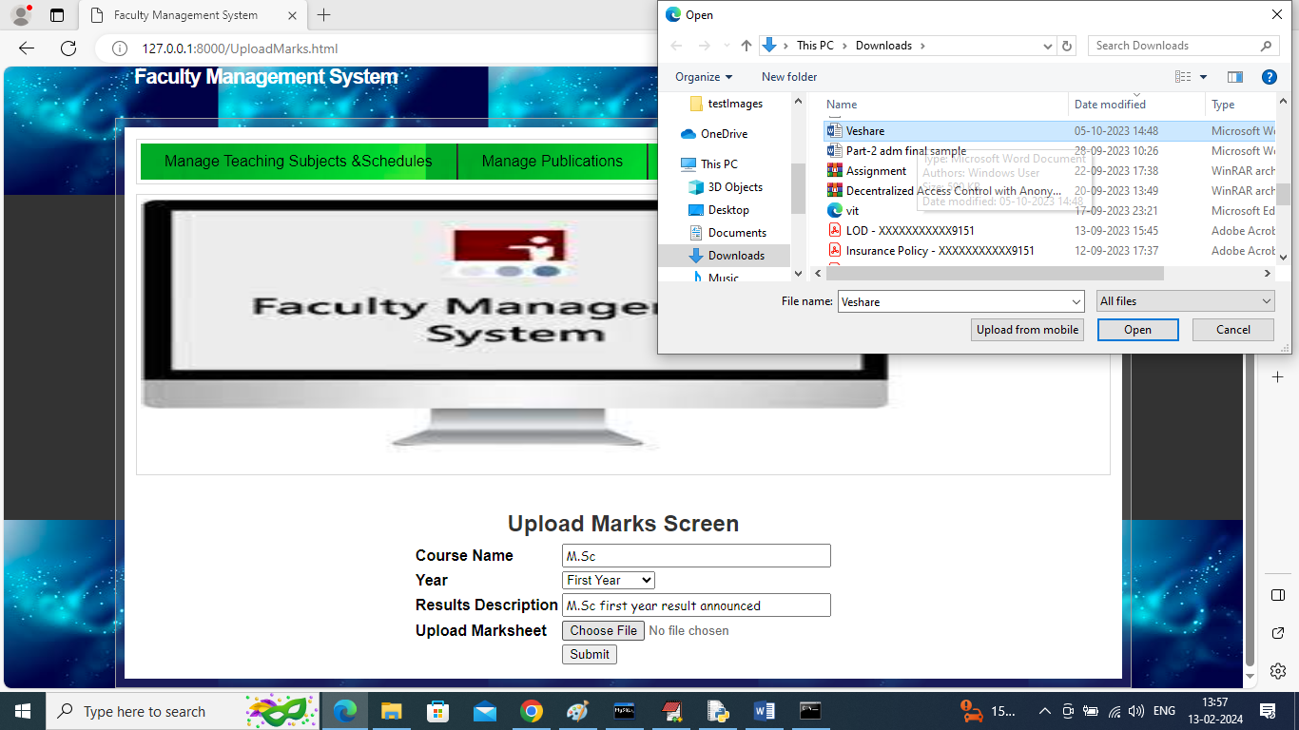

In above screen faculty will add mark sheet details and upload the file and then click on ‘Open’ and ‘Submit’ button to save ark details

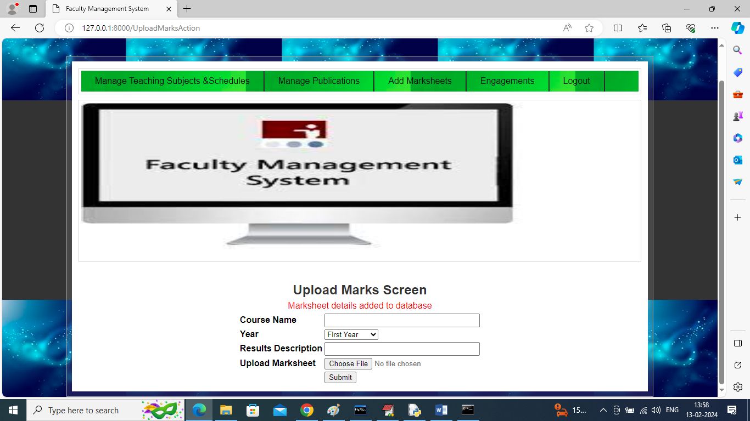

In above screen mark details added to database and then click on ‘Engagements’ link to add his engagement details

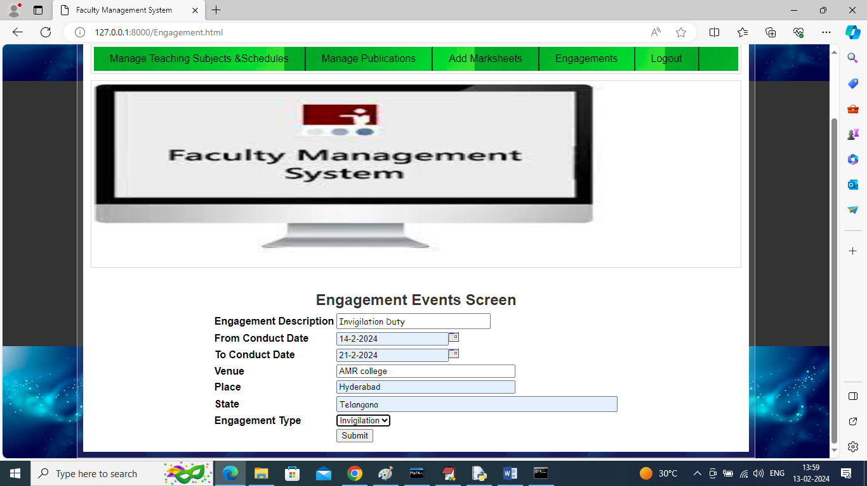

In above screen faculty adding all his engagement details and then press button to get below output

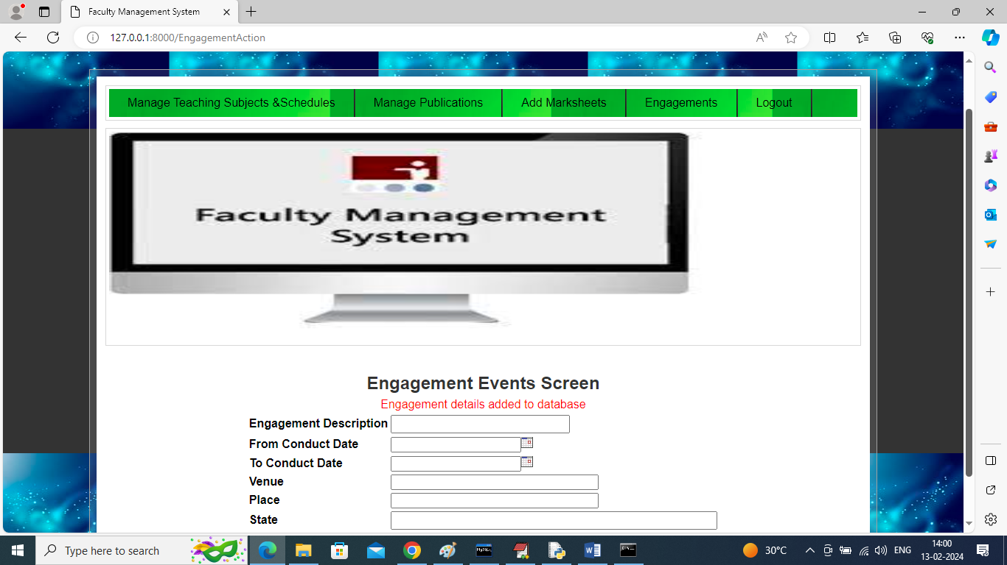

In above screen engagement details added and now logout and login as ‘Student’ to view all reporting

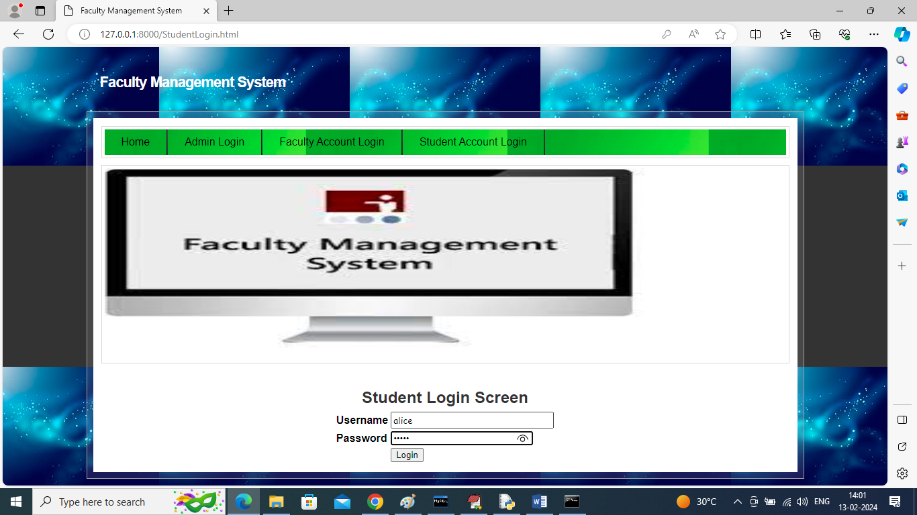

In above screen student is login and after login will get below page

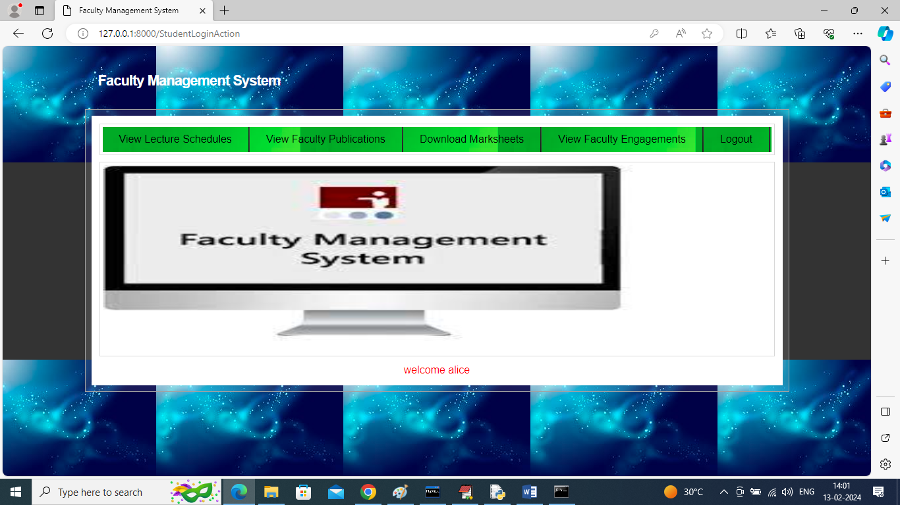

In above screen student can click on ‘View Lecture Schedules’ link to get list of scheduled lecturer

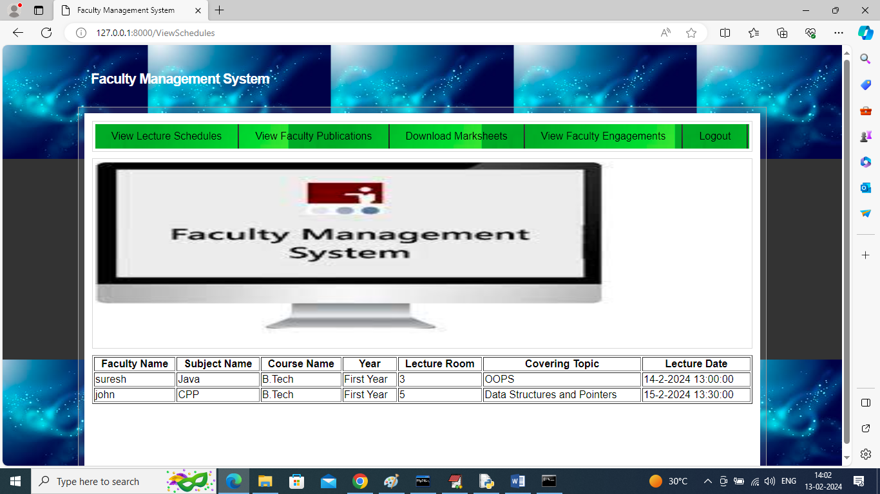

In above screen student can view list of all schedules lecturer and now click on ‘View Publication’ to view research work of all faculties for joining or assisting

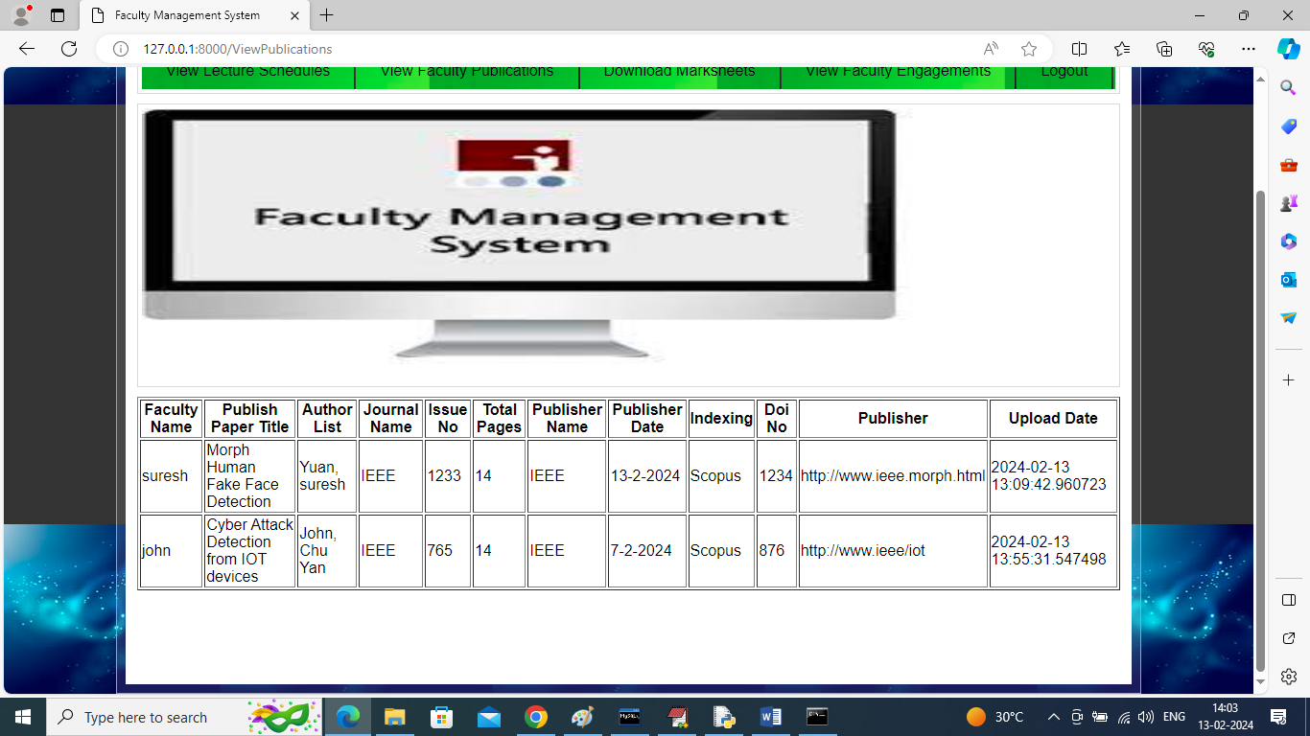

In above screen student can view research work from all faculties and now click on ‘Download Mark sheet’ link to view and download all announced results

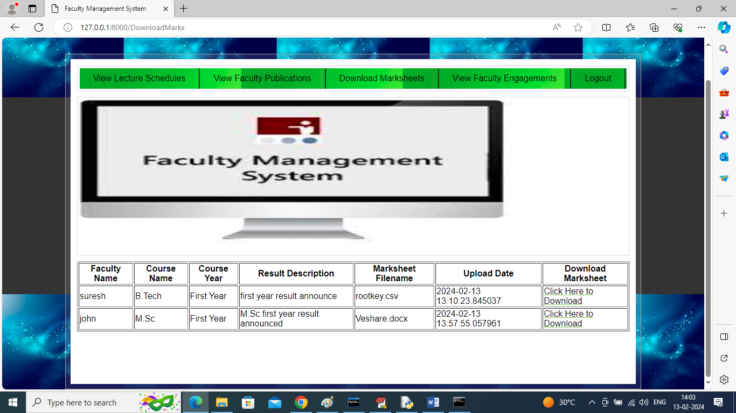

In above screen student can view all announced results and can click on ‘Click Here to Download’ link to download result and get below output

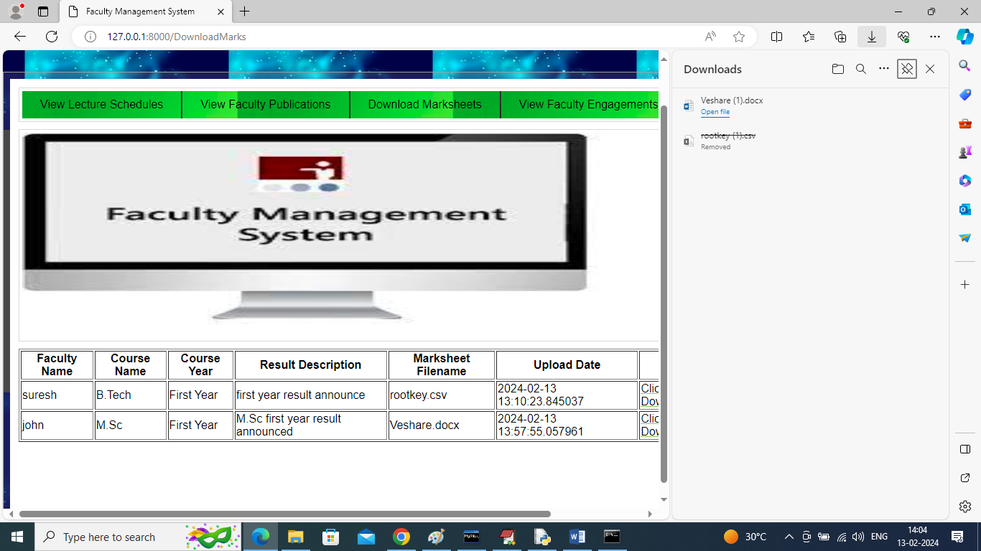

In above screen in right side panel can see downloaded marks sheet and now click on ‘View Faculty Engagements’ to know about faculties and their engagements

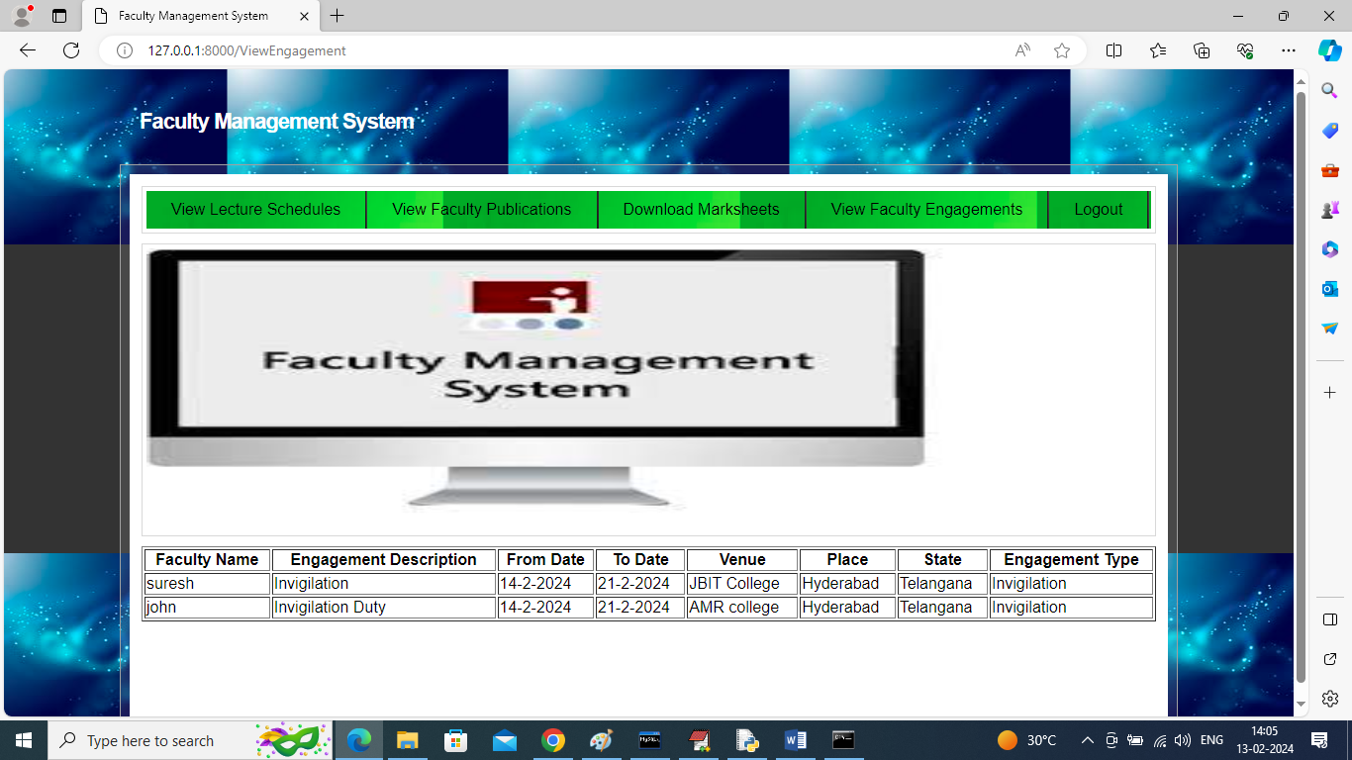

In above screen student can view which faculties are engage in which engagement type.

Similarly by following above screens faculties will feed online all details and students can view all those details